Performance Testing

Date | 24 September 2026
Team ID | SWTID-2026-1838
Project Name | AI FitTrack API
Maximum Marks | 5 Marks

Performance Testing
Performance testing evaluates how the FitTrack application behaves during normal usage. The main purpose is to check whether important features such as Login, Registration, Profile Management and Dashboard respond properly without noticeable delay.

Step 1: Testing Overview
Field | Details
Development Tool Used | Visual Studio Code (VS Code)
Testing Approach | Functional and Response Testing
Target Features | User Registration, User Login, Profile Management and Fitness Dashboard
Test Environment | Local Development Environment
Test Date | 24/09/2026

Tool Used – Visual Studio Code
Visual Studio Code (VS Code) was used to develop and run the FitTrack application. The FitTrack features such as User Registration, User Login, Profile Management and other application modules were developed and tested in the local development environment using VS Code.
Screenshot to add: Add a screenshot of the FitTrack project running from VS Code or the VS Code project/code screen.

Step 2: Test Scenarios

S.No | Test Scenario / Description | Test Users | Test Duration | Expected Outcome
1 | Test the User Registration feature by entering valid user details and creating an account. | 1 | Normal usage | Registration should complete successfully without noticeable delay.
2 | Test the User Login feature using valid login credentials. | 1 | Normal usage | User should be logged in successfully and redirected to the application.
3 | Test the Profile Management feature by viewing and updating user information. | 1 | Normal usage | Profile information should load and update correctly.
4 | Test the Fitness Dashboard by loading the user's fitness information and progress. | 1 | Normal usage | Dashboard information should load correctly without noticeable delay.

Step 3: Performance Test Results

S.No | Metric | Target Value | Actual Value | Status
1 | Login Response | Quick response | To be observed during testing | To be updated
2 | Registration Response | Quick response | To be observed during testing | To be updated
3 | Profile Loading | Quick response | To be observed during testing | To be updated
4 | Dashboard Loading | Quick response | To be observed during testing | To be updated

Step 4: Observations & Analysis
The FitTrack application was tested in the local development environment using the application developed through Visual Studio Code. The main features tested were User Registration, User Login, Profile Management and Fitness Dashboard.
During testing, the application was checked for proper loading and response while performing the main user operations. The features should respond correctly and display the required information without noticeable delay.

Step 5: Screenshots / Evidence

Screenshot 1 – FitTrack Login Page

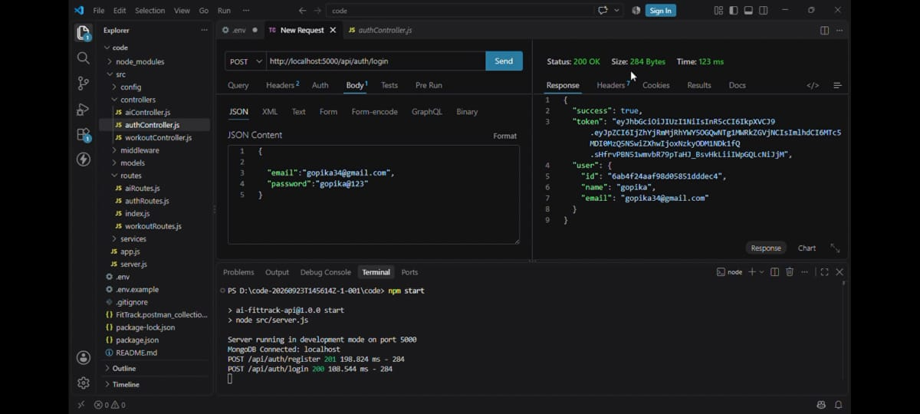

Screenshot 2 – FitTrack Registration Page

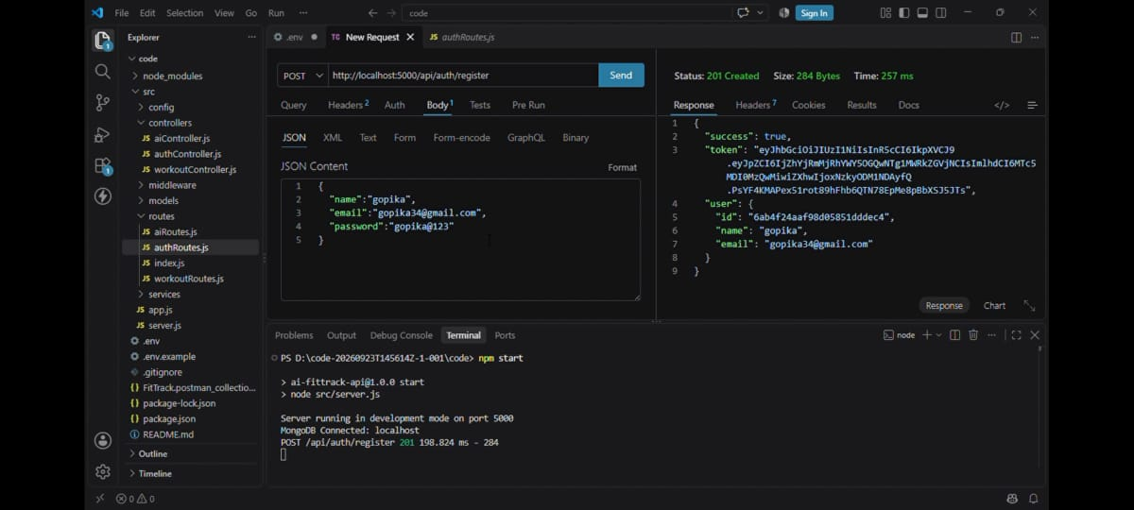

Screenshot 3 – FitTrack Profile Page

